**Substation Structural Solution**

Contents

Introduction: 3

Specification: 3

Workflow: 3

GUI: 4

Usage method: 4

Remarks: 4

Appendix: 4

# Introduction:

This document covers the summary of requirements for the single horizontal leg brace connection

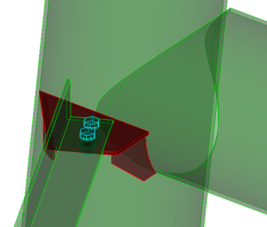

# Specification:

This connection has the following requirements over and above “General UI guidelines for ProStructure User Connections”:

* support and branch shapes can be pipe or HSS/square rectangular tube
* Connecting shape are restricted to equal and unequal angles
* Support, brace and connecting shapes should exist
* 3 plates are created by the connection (see illustrations below) + bolts or welding (similar parameters to PS web angle connection)

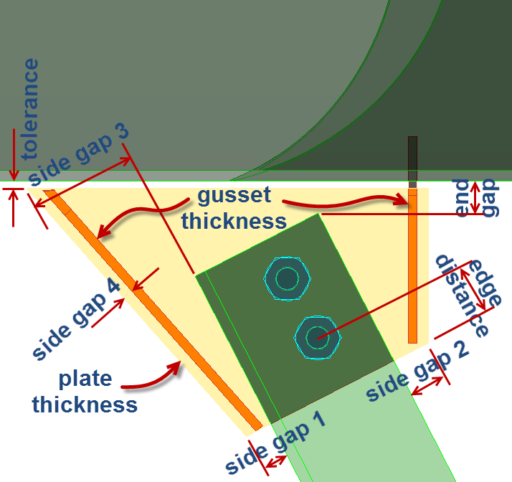 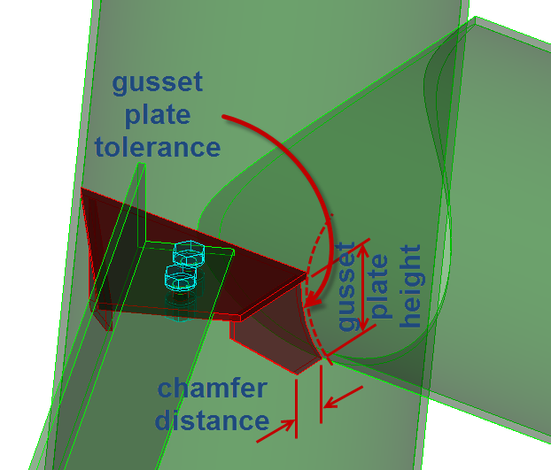

* This connection should work in both scenarios connecting shape as shown in above illustration and when connecting shape are turned downward.
* Grouping:
  + If supporting shape is part of an existing group, then 3 red plates should be added to that group
  + If supporting shape is not part of an existing group, then a group should be created with the supporting shape as the main part of the group and 3 red plates as subparts of the group.
* Provide 2 assignment elements, one for plate and the other for gusset.

# Workflow:

User will select the supporting shape/leg followed by selecting the branch/horizontal and finally the connecting shapes/brace

# GUI:

…..

# Usage method:

User will select the supporting shape/leg followed by selecting the branch/horizontal and finally the connecting shapes/brace

# Remarks:

…..

# Appendix:

…..